**Підготовка даних для побудови звітів у BI системах (Preparation of data for building reports in BI systems)**

SELECT

  DISTINCT DATE(TIMESTAMP_MICROS(event_timestamp)) AS event_timestamp,

  user_pseudo_id,

  (

  SELECT

    value.int_value

  FROM

    e.event_params

  WHERE

    KEY = 'ga_session_id') AS session_id,

  event_name,

  geo.country,

  device.category AS device_category,

  traffic_source.source,

  traffic_source.medium,

  traffic_source.name AS campaign

FROM

  `bigquery-public-data.ga4_obfuscated_sample_ecommerce.events_20210131` e

WHERE

  event_date BETWEEN '20210101'

  AND '20211231'

LIMIT

  100

Result

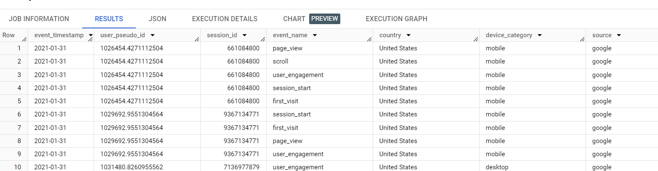

## **Розрахунок конверсій в розрізі дат та каналів трафіку (Calculation of conversions in terms of dates and traffic channels)**

WITH

  events AS(

  SELECT

    user_pseudo_id,

    DATE(TIMESTAMP_MICROS(event_timestamp)) AS event_date,

    traffic_source.source AS traffic_source,

    traffic_source.medium AS medium,

    traffic_source.name AS campaign,

    event_name,

    (

    SELECT

      value.int_value

    FROM

      e.event_params

    WHERE

      KEY = 'ga_session_id') AS session_id

  FROM

    bigquery-public-data.ga4_obfuscated_sample_ecommerce.events_20210131 e),

  session AS (

  SELECT

    user_pseudo_id,

    session_id

  FROM

    events

  WHERE

    event_name = 'session_start'),

  cart AS (

  SELECT

    user_pseudo_id,

    session_id

  FROM

    events

  WHERE

    event_name = 'add_to_cart'),

  checkout AS (

  SELECT

    user_pseudo_id,

    session_id

  FROM

    events

  WHERE

    event_name = 'begin_checkout'),

purchase AS (

  SELECT

    user_pseudo_id,

    session_id

  FROM

    events

  WHERE

    event_name = 'purchase')

SELECT

  event_date,

  traffic_source,

  medium,

  campaign,

  count (DISTINCT e.user_pseudo_id ||'/'|| CAST(e.session_id AS string)) AS user_sessions_count,

  round((count(distinct c.user_pseudo_id || cast(c.session_id as string)) /count(distinct s.user_pseudo_id || cast(s.session_id as string)))*100,2) as cr_visit_to_cart,

round((count(distinct ch.user_pseudo_id || cast(ch.session_id as string))/ count(distinct s.user_pseudo_id || cast(s.session_id as string)))*100,2) as cr_visit_to_checkout,

round((count(distinct p.user_pseudo_id || cast(p.session_id as string))/ count(distinct s.user_pseudo_id || cast(s.session_id as string)))*100,2)as cr_visit_to_purchase

FROM

  events e

left join session s on s.user_pseudo_id = e.user_pseudo_id

left join cart c on c.user_pseudo_id = e.user_pseudo_id

left join checkout ch on ch.user_pseudo_id = e.user_pseudo_id

left join purchase p on p.user_pseudo_id = e.user_pseudo_id

GROUP BY

  1,

  2,

  3,

  4

LIMIT

  100

Result

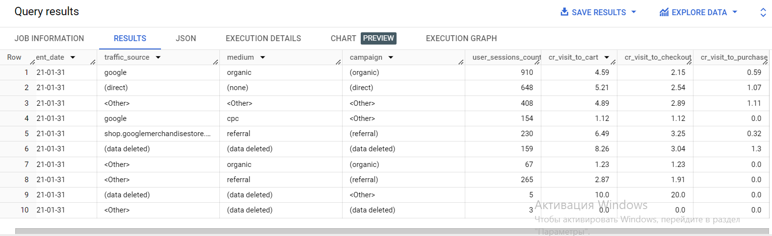

## **Порівняння конверсії між різними посадковими сторінками (Comparison of conversion between different landing pages)**

with page_p as (

select distinct (select value.string_value

from e.event_params where key = 'page_location') as page_path,

(

    SELECT

      value.int_value

    FROM

      e.event_params

    WHERE

      KEY = 'ga_session_id') AS session_id,

user_pseudo_id,

event_name

from bigquery-public-data.ga4_obfuscated_sample_ecommerce.events_20210131 e

),

purchase AS (

  SELECT

    user_pseudo_id,

    session_id

  FROM

    page_p

  WHERE

    event_name = 'purchase'),

session AS (

  SELECT

    user_pseudo_id,

    session_id

  FROM

    page_p

  WHERE

    event_name = 'session_start')

select REGEXP_EXTRACT(page_path, r'(?:[a-zA-Z]+://)?(?:[a-zA-Z0-9-.]+)/{1}([a-zA-Z0-9-./]+)') as path,

count (DISTINCT page_p.user_pseudo_id ||'/'|| CAST(page_p.session_id AS string)) AS user_sessions_count,

count (DISTINCT p.user_pseudo_id ||'/'|| CAST(p.session_id AS string)) as count_purchase,

round((nullif (count (DISTINCT p.user_pseudo_id ||'/'|| CAST(p.session_id AS string)),0)/ nullif (count (DISTINCT s.user_pseudo_id ||'/'|| CAST(s.session_id AS string)),0))*100,2) as cr_session_to_purchase

from page_p

left join purchase p on p.user_pseudo_id = page_p.user_pseudo_id

left join session s on s.user_pseudo_id = page_p.user_pseudo_id

group by 1

order by 1 asc

limit 100

Result

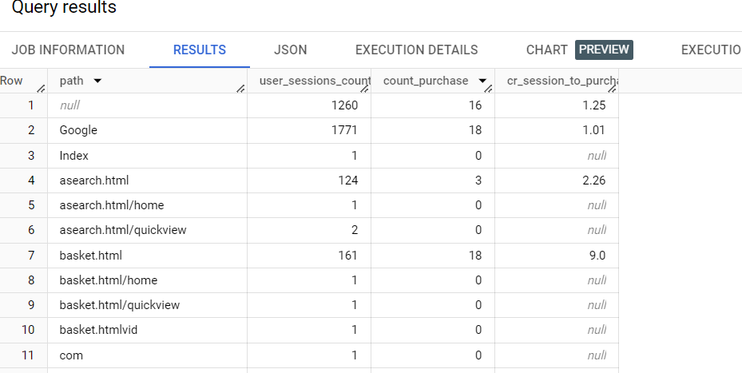

## **Перевірка кореляції між залученістю користувачів та здійсненням покупок (Testing the correlation between user engagement and purchases)**

with events as (

  select event_name,

date (timestamp_micros(event_timestamp)) as event_date,

user_pseudo_id,

(select value.int_value

from b.event_params

where key = 'ga_session_number') AS session_id,

(select value.string_value

from b.event_params

where key = 'session_engaged') AS session_engaged,

(select value.int_value

from b.event_params

where key = 'engagement_time_msec') AS engagement_time_msec

from bigquery-public-data.ga4_obfuscated_sample_ecommerce.events_20210131 b

),

purchase as (

  select user_pseudo_id,

  session_id

from events

  where  event_name = 'purchase'

),

events_metrics as(

select distinct e.user_pseudo_id || cast(e.session_id as string) as user_sessions,

case when sum(coalesce(cast (session_engaged as int),0)) >0 then 1

else 0

end as total_session_engaged,

sum(engagement_time_msec) as total_engagement_time,

count (distinct p.user_pseudo_id || cast(p.session_id as string)) as purchase_made

from events e

left join purchase p using (user_pseudo_id,session_id)

group by 1)

select

round (corr (total_session_engaged,purchase_made),4) as corr_eng_pur,

round (corr (total_engagement_time,purchase_made),4) as corr_engtime_pur

from events_metrics

limit 100

Result

